BONDED WIRE RETAINER

Q What is a bonded wire retainer?

A A bonded wire retainer is a small wire glued to the inside of the top or bottom front teeth.

Q How does the bonded retainer work?

A As the wire retainer is both fixed to the teeth but still flexible it prevents the teeth moving out of line after a brace has been removed.

Q Will it hurt?

A There should be no pain or discomfort.

Q How do I clean my teeth & the retainer?

A Extra care must be taken when cleaning your teeth and the wire retainer.

Q How long will the retainer need to be in place?

A As long as the retainer is intact it is better to leave it in place. Removal may allow the teeth to move even years later.

Q Will there be any permanent damage?

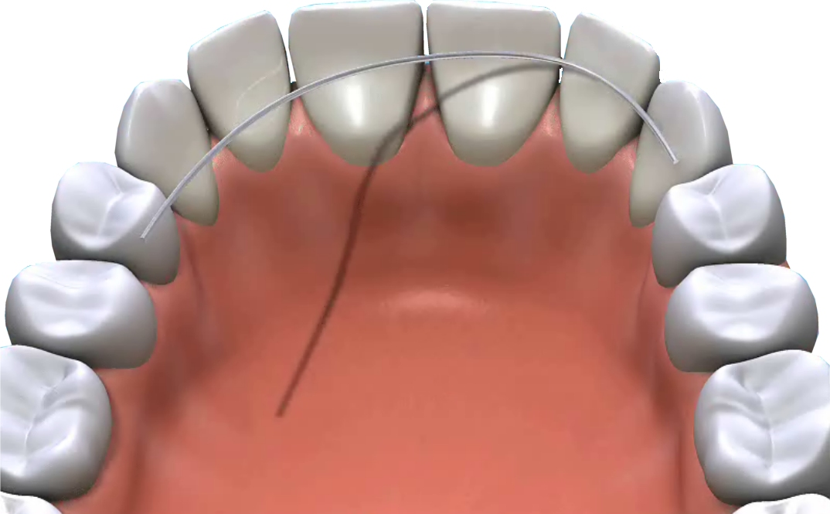
A Poor cleaning and too many fizzy drinks can cause permanent decay marks. The importance of thorough brushing and the use of a fluoride mouthwash cannot be emphasised enough.

Q How often should I return for check-ups?

A The retainer can be checked by your family dentist at your usual check ups.

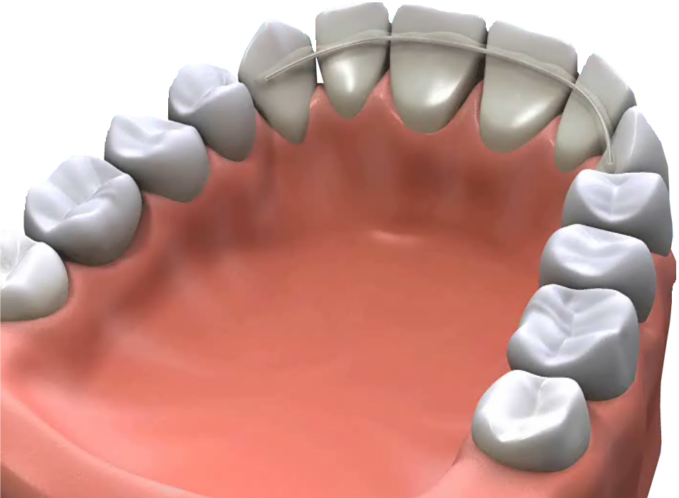
Q How successful will it be?

A Occasionally the wire retainer will need repairing or replacing. Your dentist at your regular check ups will discuss this with you.

